Professional Skills assignment 6
Q. 1. What is a list, explain with examples, paste your code and output. (2 points).
Lists are written within square brackets, they store an ordered collection of items which can be different types.
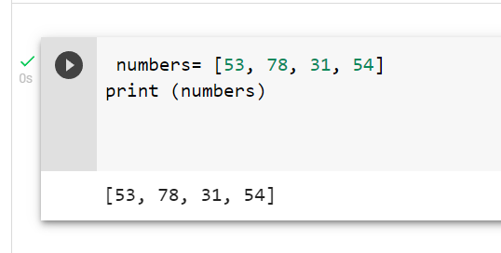
Q. 2. What is a dictionary, explain with examples, paste your code and output. (2 points)
Dictionaries are pythons implementation of data structure that is more generally known as an associative array
It consists of a collection of key value pairs and each key-value pair maps the key to its associated value
You can construct dictionaries with dict()
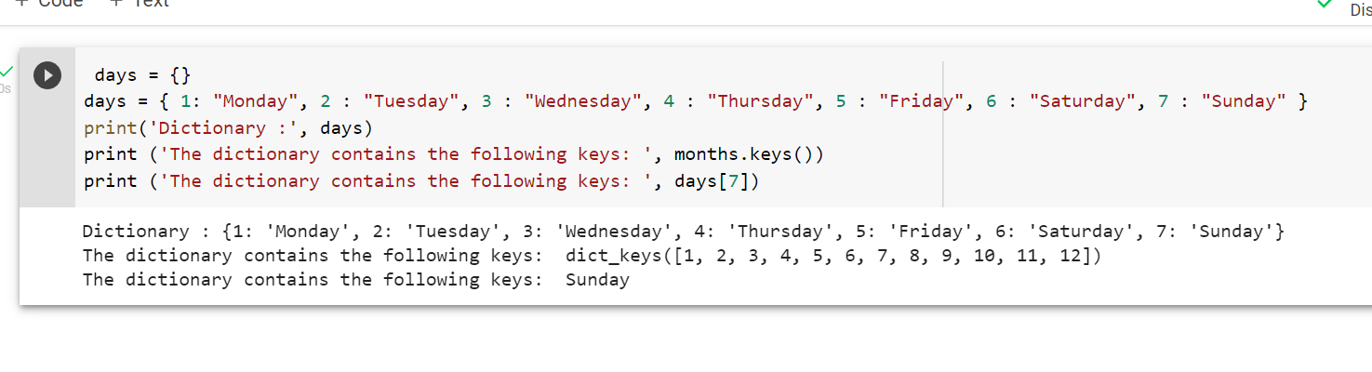
Q. 3. What is set, explain with examples, paste your code and output. (2 points)
A set is created using curly brackets {} with elements separated by a comma. The elements may be different types (integer, float, string etc). They are immutable and cant be duplicated.
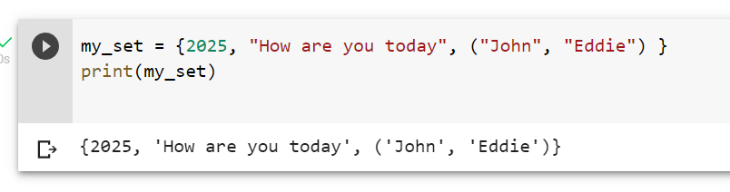
Q. 4. What is a tuple, explain with examples, paste your code and output. (2 points)
A tuple is another ordered collection of objects. Tuples are identical to lists, except for the following: Tuples are defined by enclosing the elements in parentheses () instead of square brackets and tuples are immutable.
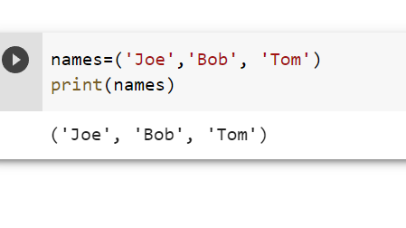

Q. 5. Differentiate between dictionary and set, give example code, output, and paste it. (2 points)
Dictionaries are ordered and changeable data structures whereas sets are not eg dictionary: {1: “hi”, 2:”Hello”} set{“Hi”,”Hello”}
Sets are created by using set() function, they are used to join operations and to find unique values.
On the other hand dictionaries are created using dict(). Dictionaries are used to crate data frame with lists as well as being used in JSON.
Dictionaries store data types in curly brackets in the form 1:input, sets just used curly brackets as they are not ordered.
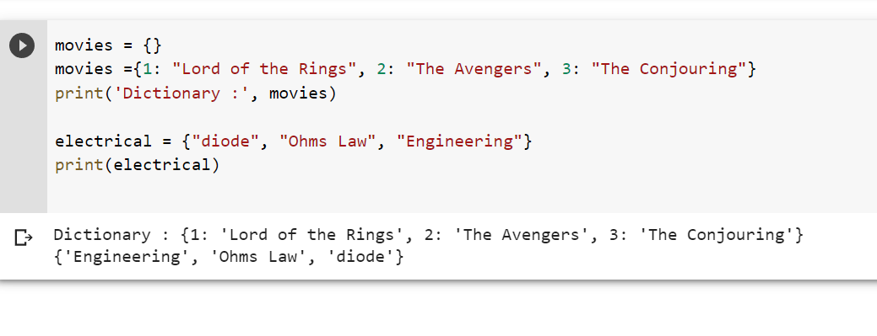
Dictionary is first, set is second

